**Task 1: Scan Your Local Network for Open Ports**

**Step 1: Install Nmap from** [**https://nmap.org/download**](https://nmap.org/download) **(Windows)**

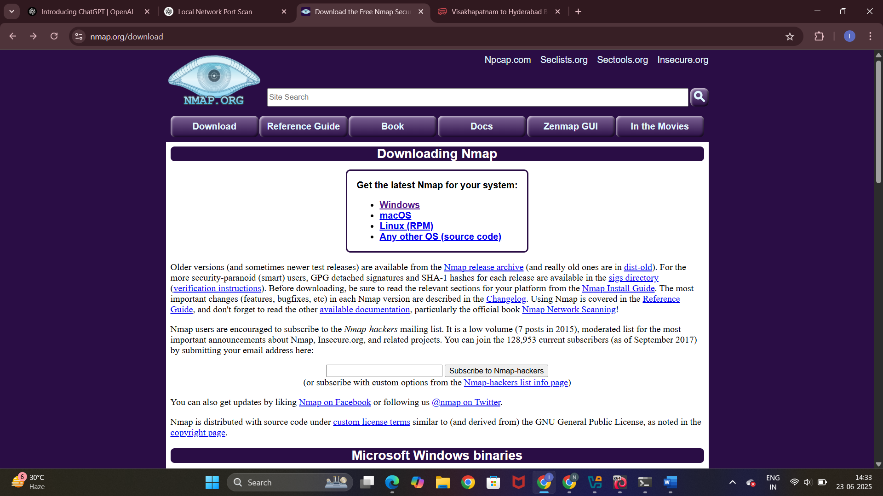

**Sudo apt install nmap (Linux)**

**/home/kali/Documents/Screenshot_2025-06-23_05_04_13.png**

**Step 2: ipconfig (Windows)**

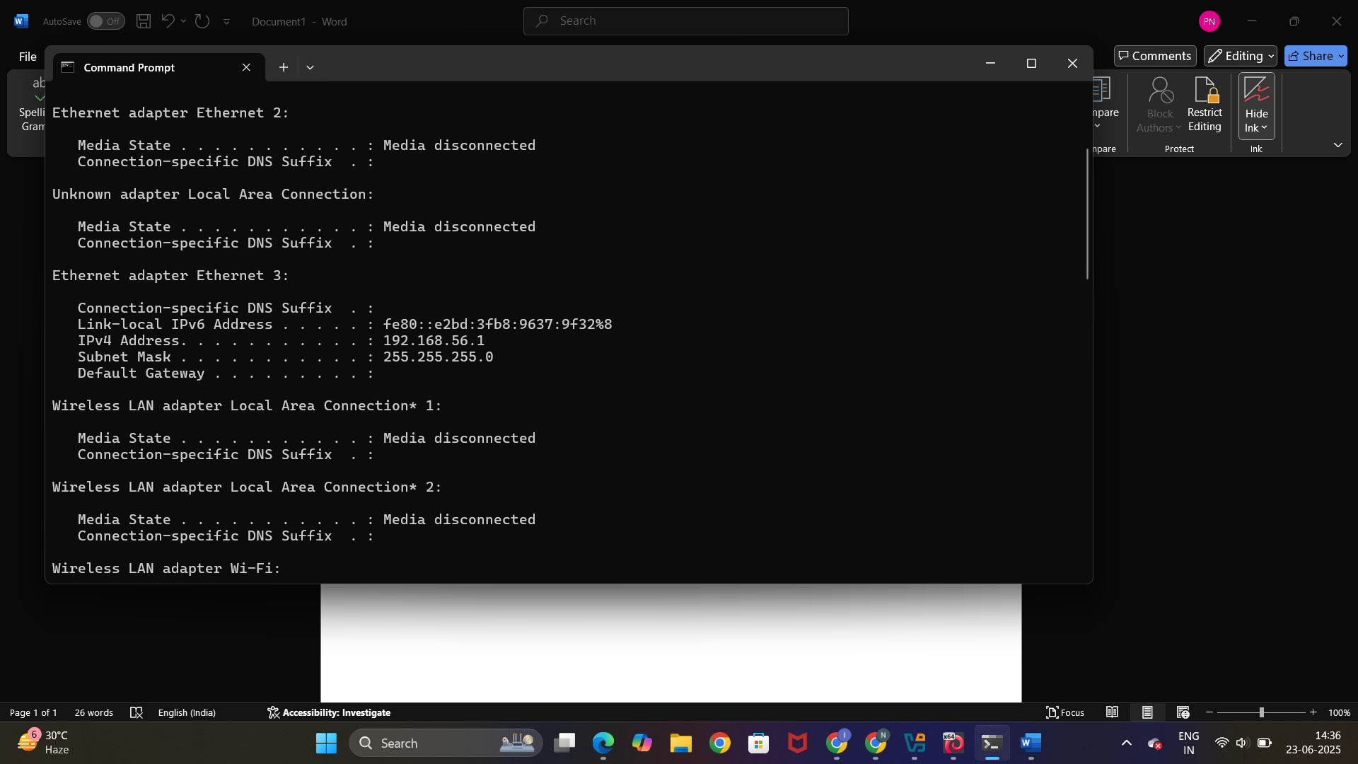

**Step 3: nmap -sS <ip address>**

**-sS performs a TCP SYN scan**

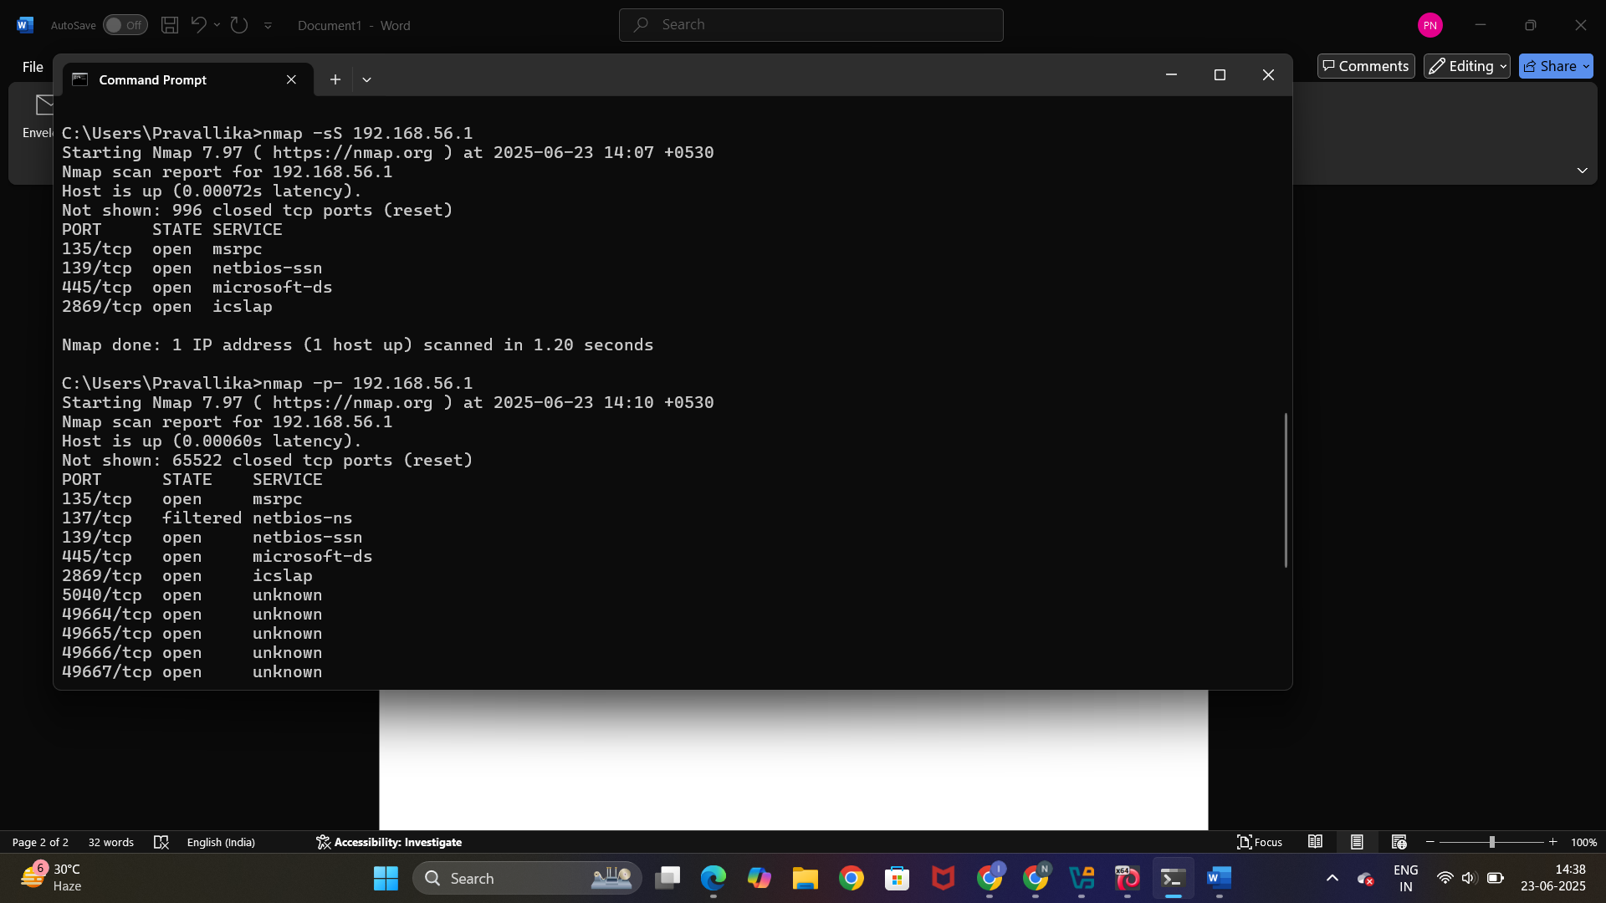

**Step 4:**

**nmap -p- <ip address>**

**-p- scans all ports**

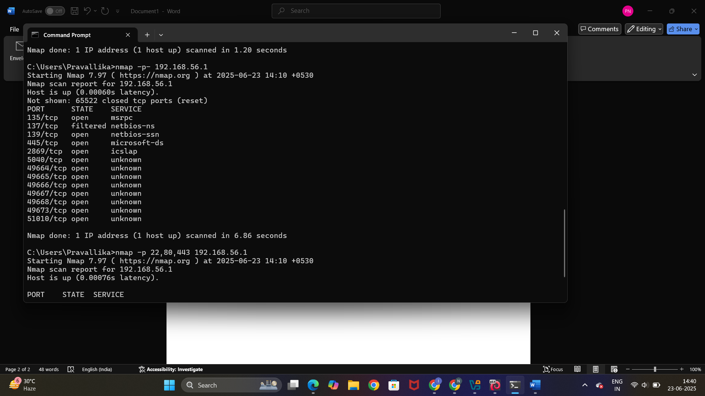

**Step 5: nmap -p 22,80,443 <ip address>**

**-p 22,80,443 scans selected details of selected ports**

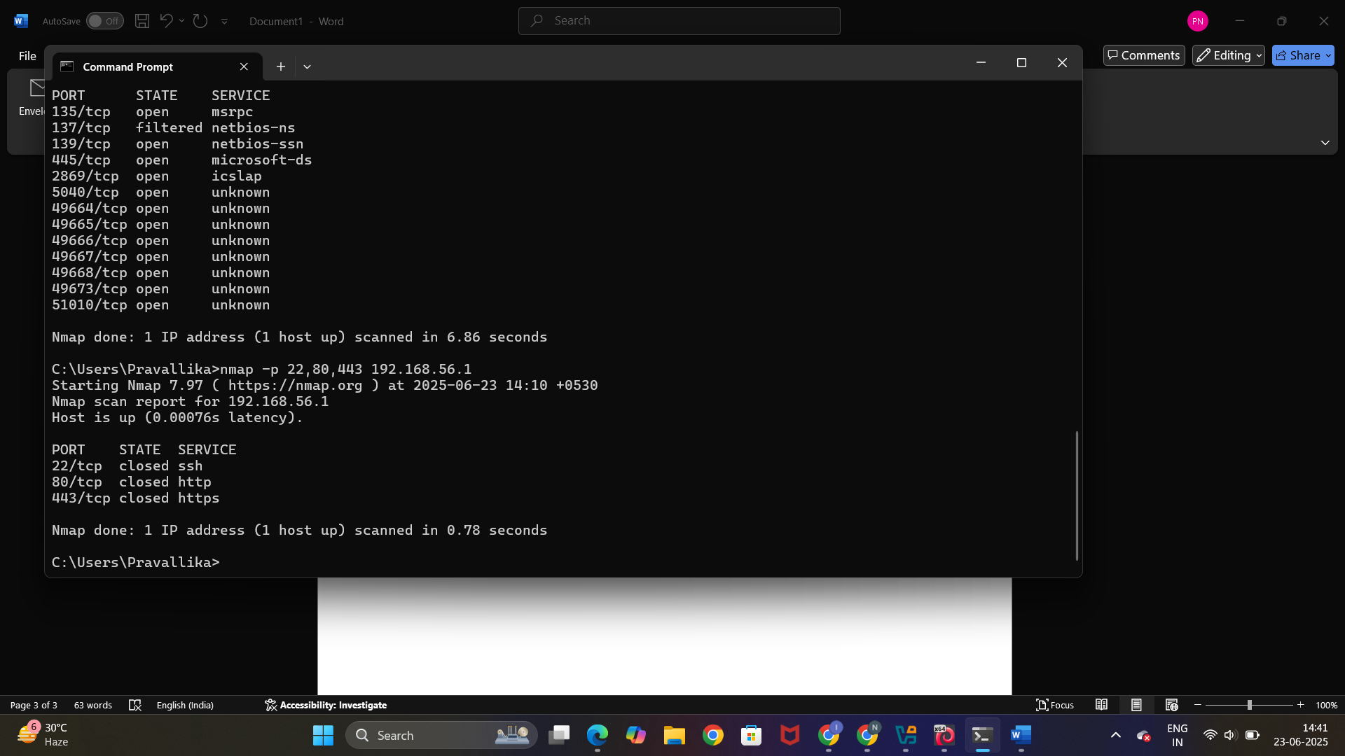

**Note: Same commands are used in Linux as will**

**Where as in windows we use command prompt**

**In Linux we use Terminal**